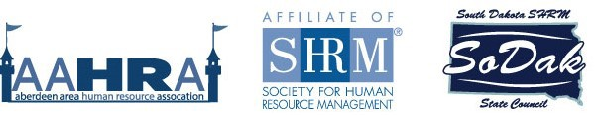

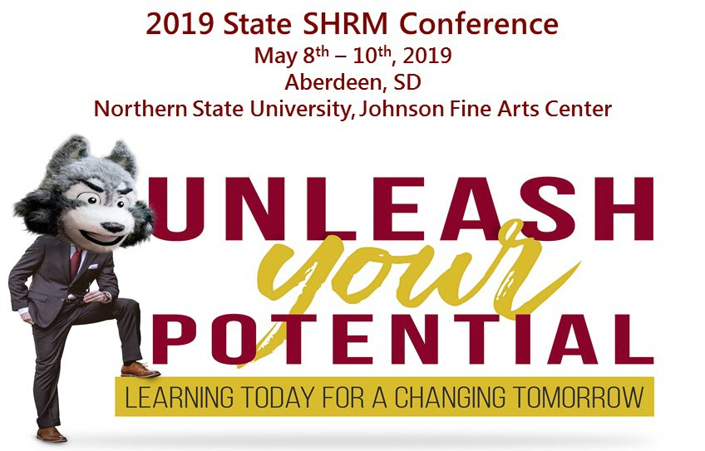

Click here to register!
More information can be found at AAHRA’s website: https://aahra.shrm.org
SoDak State SHRM Council’s website: www.sodakshrm.org
Join us on Facebook: @AberdeenAreaHRAssociation @SoDakSHRM

Conference Registration Fees

About The Event Please register each attendee separately. You need to provide additional information regarding each attendee. Thank you for your assistance in providing a smooth registration process during the conference!

Cancellation Policy If you find you are no longer able to attend, please contact Diane Lewandowski, dianel@precisionwallsystems.com– (605)-448-2929. Cancel prior to April 20, 2019 for a 50% refund. We will not be able to offer a refund April 20 or later.
Early Bird Cash | $225
Early Bird Credit Card | $235
Cash – After March 31st | $275
Credit Card – After March 31st | $285
1 Day Cash | $100
1 Day Credit Card | $110
Student Rate | $99
Guest Meal | $25

Accommodations
AmericInn – 301 Centennial Street, Aberdeen, SD 57401; (605) 225-4565 $109.00/night
**Location for nightly dinners and entertainment venue

My Place Hotel – 410 S. Harvard Street, Aberdeen, SD 57401 (605) 262-4600 $75.00/night
**Reference SD HR Conference
Questions? Contact our conference chairs: Kim Bowman – kim.bowman@dacotahbank.com
Kristin Kroell – kristin.kroell@agtegra.com

Conference Agenda – At a Glance!
Northern State University
Johnson Fine Arts Center (JFAC)
12th Ave Southeast

Wednesday, May 8th, 2019
Time | Session / Speaker
11:00 – 1:00 p.m. | State Council Meeting (State Council Members only)
12:00 – 4:00 p.m. | Registration
1:30 – 2:00 p.m. | Welcome & Opening Remarks – Conference Co-Chairs, Kim Bowman & Kristin Kroell / Northern State University President, Dr. Tim Downs / American Legion presents Colors
2:00 – 3:15 p.m. | Leading Change: How HR Gets a Seat at the Table Today – Scott Carbonara
3:15 – 3:45 p.m. | Afternoon Break
3:45 – 5:00 p.m. | Break Out  Sessions | Understanding the FMLA/ADA Process – Patricia Dougherty, Weston Group
 |  | The Power of HR as a Strategic Business Partner – Michael Hepperlen, MDA Leadership & Paul Georgoff, Dacotah Bank
 |  | Department of Labor: The Workforce Landscape and Filling the Gap – Marcia Hultman, SD Cabinet Secretary

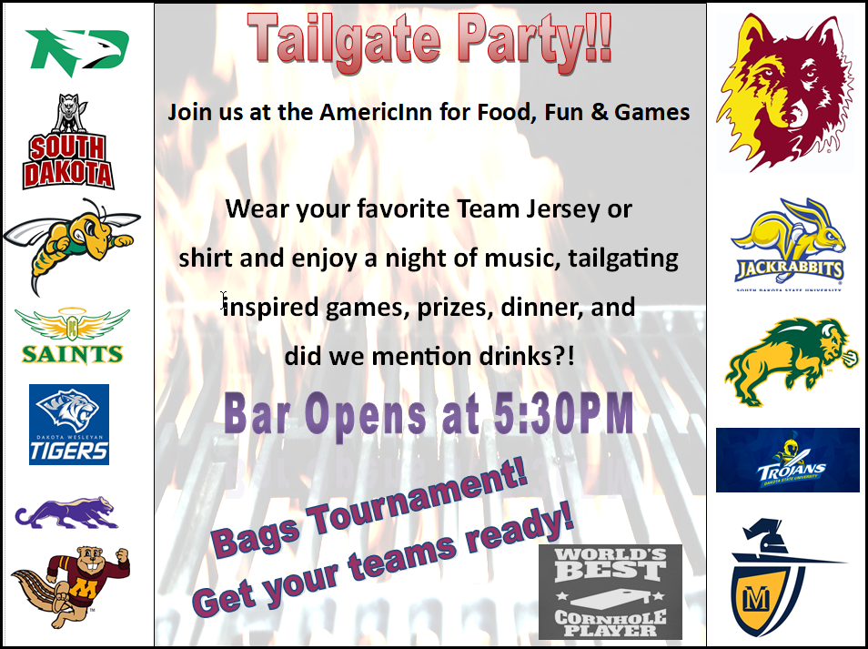

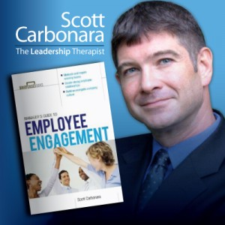Scott Carbonara is a speaker, trainer, author, and consultant who "brings authentic leadership to life from the boardroom to the family room." Scott is known as "The Leadership Therapist" for his diverse professional portfolio-ranging from serving as an award-winning family crisis intervention counselor-to executive director of communications and change management and eventually chief-of-staff of the nation's largest non-investor-owned health insurance company. While there, he addressed a skyrocketing 38% attrition rate and, through digging beyond the surface and implementing creative employee engagement initiatives and branding of a positive corporate culture, led the team that reduced it to an unprecedented 6.5%. Scott's dual background in both counseling and executive leadership makes him a highly-skilled, passionate communicator and problem solver who provides direction to diverse teams ranging in size from 1 to 13,000. Scott has spoken at international conferences and for such esteemed groups as Chicago Booth School of Business and is the author of several leadership books. Through his humorous and practical keynotes, executive coaching, management consulting, and story-driven books, he breathes life into leadership initiatives including employee engagement, change management, communication, positive culture, and customer service. Like a houseplant which grows towards the light, Scott aims to inspire people everywhere to lead by living positively and paying it forward. https://leadershiptherapist.com/
Thursday, May 9th, 2019
Time | Session / Speaker
7:30 – 4:00 p.m. | Registration
7:00 – 7:50 a.m. | Breakfast
8:00 – 8:30 a.m. | Welcome & Opening Remarks – Sheila Mennenga, State Council Director, Nancy Conway, SHRM Field Services Director, Legislative Updates: Secretary of Labor, Marcia Hultman, Julie Johnson and Leah Brink, Daktronics
8:30 – 10:00 a.m. | Our Changing Tomorrow: The Future of HR – Jennifer McClure, Unbridled Talent, LLC. And DisruptHR, LLC.
10:00 – 10:30 a.m. | Morning Break – Visit Vendors
10:30 – 12:00 p.m. | Break Out Sessions | Performance Management/Conflict Resolution – Mary Jo Vance, Weston Group
 |  | Hiring and Recruiting in Changing Times – Jen Strand and Lisa Tillotson Jobs HQ
 |  | Diversity and Inclusion Panel – NSU / Molded Fiber Glass / Dakota Provisions
12:00 – 1:00 p.m. | Networking Lunch
1:00 – 2:15 p.m. | Break Out Sessions | EEOC – Maria Flores
 |  | When The Hammer Falls – Cynthia Bremer, Ogletree Deakins Law Firm
 |  | Mental Health 1st Aid – Amy Sanderson, Northeastern Mental Health
2:15 – 2:45 p.m. | Afternoon Break
2:45 – 4:00 p.m. | Employment Law Challenge – Hal Shillingstad, Ogletree Deakins Law Firm and Michael McKnight, Boyce Law Firm
4:00 – 5:00 p.m. | Communicating in a Changing Workplace – Dr. Thom Flamboe, Race Wheels, LLC.

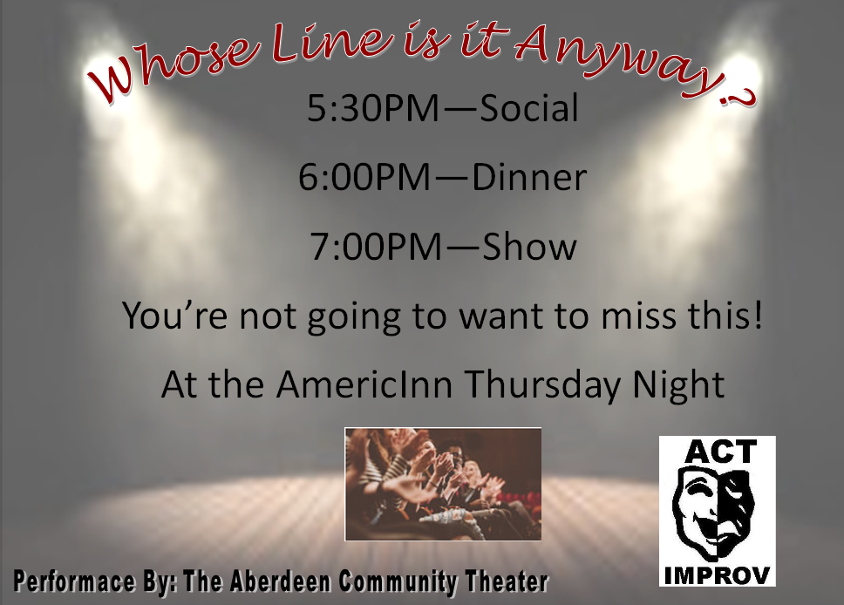

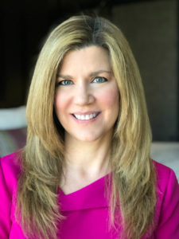Jennifer McClure is an entrepreneur, high performance coach, and former HR executive who works with business leaders to build their influence, think strategically, and create maximum positive impact at work and in life. As a top-rated international speaker and CEO of Unbridled Talent, Jennifer is recognized as an influencer and expert on strategic leadership and innovative people strategies, and she’s delivered programs to over 50,000 people around the world. As host of the popular weekly podcast – Impact Makers with Jennifer McClure – she shares conversations with practitioners, entrepreneurs, authors and speakers who are changing the world, as well as tools, tips, resources and information to help leaders build careers that they love and lives that matter. Jennifer is also the Chief Excitement Officer of DisruptHR, a global community designed to energize, inform and empower business leaders who are interested in disruptive ideas and moving the collective thinking forward when it comes to talent in the workplace. https://jennifermcclure.net/speaking/#topics

Friday, May 10th, 2019
Time | Session / Speaker
7:00 – 7:50 a.m. | Breakfast / Leadercast Registration
8:00 – 9:30 a.m. | Leadercast – Facilitated by Dr. Thom Flamboe
9:30 – 10:00 a.m. | Morning Break
10:00 – 11:30 a.m. | Leadercast
11:30 – 12:00 p.m. | Closing Remarks for State Conference attendees and Door Prizes for State Conference
12:00 – 12:45 p.m. | Lunch
12:45 – 2:30 p.m. | Leadercast
2:30 – 3:00 p.m. | Closing Ceremonies
Hosted by Tripp Crosby, Leadercast Live is the largest one-day leadership event in the world, broadcast live each year from Atlanta to hundreds of Host Sites around the globe. In 2019, Leadercast Live will bring together experts in leadership and organizational health to help attendees master the art and science of developing and leading healthy teams.

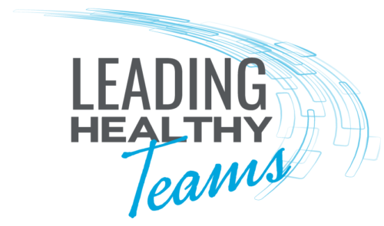As leaders, we may wonder what defines a team’s success. Is it based solely on achievement, or is there more to the story? The best leaders know a successful team is made when focus, care, attention and development are directed to its members. Healthy teams yield effective collaboration, fulfilled employees, high organizational engagement and greater long-term success. Learn what it takes to ensure your team functions at its highest and healthiest. https://live.leadercast.com
- Gayle King – Co-host, CBS This Morning and Editor-at-Large, O, the Oprah Magazine  - Patrick Lencioni – Best-Selling Author and  Founder, The Table Group  - Dr. Caroline Leaf – Communication Pathologist and Cognitive Neuroscientist  - Carla Harris -- Vice Chairman, Managing Director, Morgan Stanley | - Marcus Samuelsson – Award-Winning Chef, Restauranteur, Author and TV Personality  - Juliet Funt – CEO, WhiteSpace at Work Andy Stanley – Leadership Communicator, Author and Pastor  - Ginger Hardage – Founder, Unstoppable Cultures  - Craig Springer – Executive Director, Alpha USA
Why Attend?
- Be empowered in your leadership. Our mission is to fill the world with leaders worth following. We’re confident the lessons you’ll learn at Leadercast Live will make you a better leader.
- Learn what it means to lead a healthy team. Leadercast Live 2019 will provide you with the tools and resources you need to lead your team effectively so you can work together to bring success to your organization.
- Add to your leadership toolbox. You’ll hear a lot of wisdom from the leaders who take our stage. Each of them will share actionable tools and insights you can take with you back to your workplace.
- Hear from world-renowned experts. Our lineup of speakers will give you practical guidance on how to enhance your leader-ship, both for yourself and your team.
- Network with leaders just like you. You will be surrounded by leaders from all industries and backgrounds who are there for the same reason you are: to further themselves on their leadership journey.
- Attend Leadercast Event for no extra cost!

