

**NESD SHRM Presents:** 

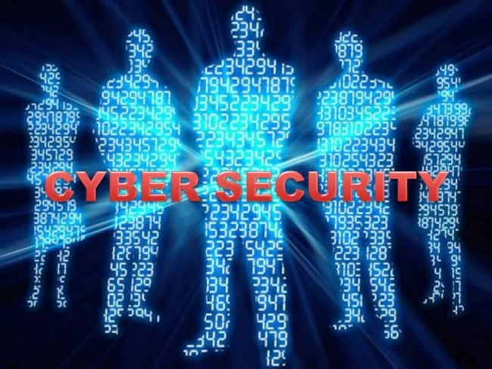

**Tuesday, February 14th**

**11:30 am – 1:00 pm**

**2nd Street Station**

**Digital & Cyber Security threats within your organization are increasing each year. The presentation will focus on all aspects of Digital & Cyber Security concerns for today’s businesses. It will cover the following areas:**

* **Threat Types**
* **Business Impact  $$$$$**
* **Prevention Strategies**
* **Mitigation & Business Continuity**
* **Litigation Risks**
* **Resources & References**

**Presented by Bryan Waege, President of Connecting Point**. Bryan has over 33 years of experience consulting, designing and implementing IT solutions in schools, businesses, and government offices. He works with businesses as small as 2 employees to Fortune 1000 companies implementing networking, server, wireless, and security solutions. Bryan brings both the business aspects and technical aspects of IT together based on his 28 years technical experience as a Senior Network Engineer and his business operations experience as President of Connecting Point.

___________________________________________________________________________________________

**RSVP at the chapter website:** [**http://nesd.shrm.org**](http://nesd.shrm.org) **(under the “Events & Education Tab”) by Friday, February 10th.**

**FREE to NESD SHRM Plus Members**

**$10 for NESD SHRM Basic Members**

**$20 for Non-NESD SHRM Members**

