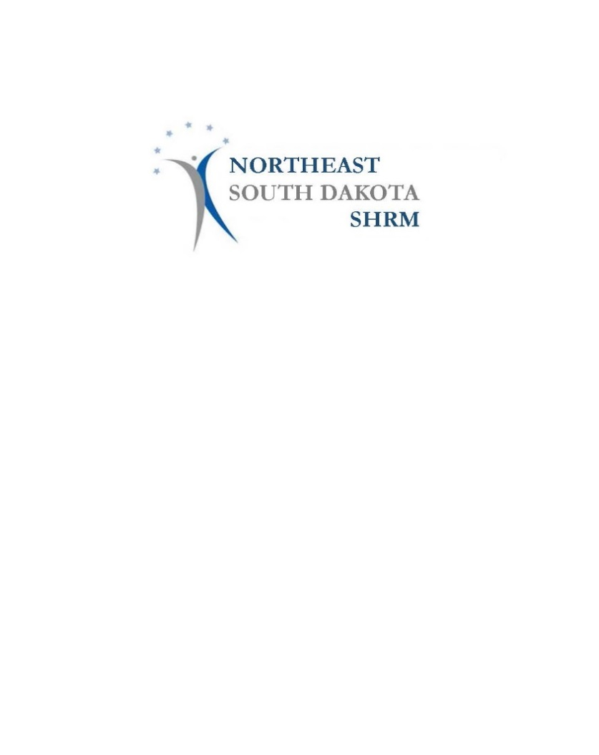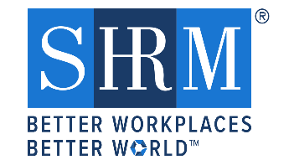

**Covid and Unemployment and All Your Questions In Between!**

**Featuring: Lisa Johnson, DOL**

Date: Tuesday, July 14, 2020

Time: 11:30 am – 12:30 pm

RSVP: nesd.shrm.org by Monday, July 13, 2020 by 10 am (Firm deadline)

July’s program will feature Lisa Johnson from the DOL answering YOUR questions on unemployment, re-employment, employees that aren’t ready to come back, and other topics that are asked by YOU!

**Please email your questions to Paige at** [**psullivan@watertownbox.com**](mailto:psullivan@watertownbox.com) **by Monday, July 13, 2020 at 10 am so Lisa has an opportunity to look over your questions.** Following this Q & A we will have a round table on the information provided, moderated by SHRM Board Member, Lynna Speier.

**\*You must be RSVP’ed by Monday, July 13, 2020 by 10 am to be included on the webinar.** You will be emailed information on how to access early Tuesday morning.

**RSVP at the chapter website:** [**http://nesd.shrm.org**](http://nesd.shrm.org) **(under the “Events & Education Tab”)**

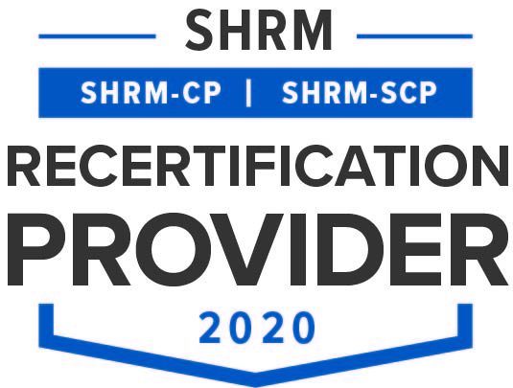

**FREE to NESD SHRM Members**