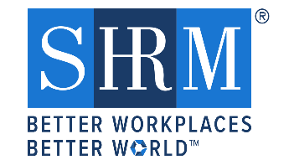

The Pursuit of Greatness
Featuring: Jennifer Reecy
Chief Employee Experience Officer
First National Bank
Date: Tuesday, September 8, 2020
Time: 11:30 am – 1:00 pm
RSVP: nesd.shrm.org by Monday, Sept 7 by 10 am (Firm deadline)

It is time for a grand revolution in your Pursuit of Leadership Greatness. That which you pursue is what you value. Leaders must be committed to the pursuit of being great leaders. You must take extreme ownership of your pursuit.
Let’s hack the principles of leadership to pull the future forward – for yourself, your teams, and your organizations. Leadership isn’t just a role or a title – it’s a choice. The best leaders choose to be different, they choose to be deliberate and purposeful in their leadership. Recognize that you are in the driver’s seat for your own leadership success, and what you pursue matters!
*You must be RSVP’ed by Monday, September 7, 2020 by 10 am to be included on the webinar. You will be emailed information on how to access early Tuesday morning.
Jennifer M. Reecy serves as the Chief Employee Experience Officer (CEEO) at The First National Bank in Sioux Falls. Through a diverse career path, Jennifer brings a depth of leadership, coaching, and consulting experience in multiple education, government, tribal, privately owned and publicly traded businesses and industries.
RSVP at the chapter website: http://nesd.shrm.org under the “Events & Education Tab”
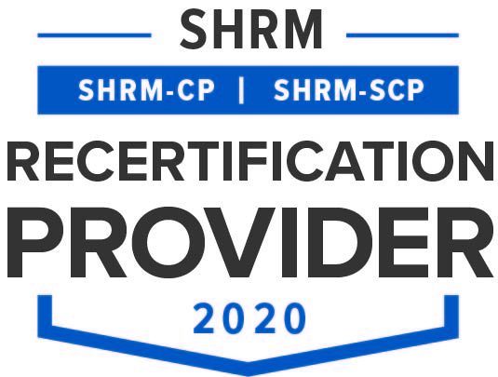
FREE to NESD and SESD SHRM Members
$20 for Non NESD and SESD SHRM Members

